Code # EN02

New/Special Course Proposal-Bulletin Change Transmittal Form
☐Undergraduate Curriculum Council - Print 1 copy for signatures and save 1 electronic copy.
☐Graduate Council - Print 1 copy for signatures and send 1 electronic copy to mmcginnis@astate.edu
xNew Course or ☐Special Course (Check one box)
Please complete the following and attach a copy of the catalogue page(s) showing what changes are necessary.

___________________Enter date…  Department Curriculum Committee Chair | ___________________Enter date…  COPE Chair (if applicable)
___________________Enter date…  Department Chair: | ___________________Enter date…  General Education Committee Chair (If applicable)
___________________Enter date…  College Curriculum Committee Chair | ___________________Enter date…  Undergraduate Curriculum Council Chair
___________________Enter date…  College Dean | ___________________Enter date…  Graduate Curriculum Committee Chair
___________________Enter date…
Vice Chancellor for Academic Affairs

1.Proposed Course Prefix and Number (For variable credit courses, indicate variable range.)
EE 4444 (5444)

2.Course Title – if title is more than 30 characters (including spaces), provide short title to be used on transcripts. Title cannot have any symbols (e.g. slash, colon, semi-colon, apostrophe, dash, and parenthesis). Please indicate if this course will have variable titles (e.g. independent study, thesis, special topics).
Intelligent Control Systems

3.Will this course be lecture only, lab only, lecture and lab, activity, dissertation, experiential learning, independent study, internship, performance, practicum, recitation, seminar, special problems, special topics, studio problems, student exchange, occupational learning credit, or course for fee purpose only (e.g. an exam)? Please choose one.
Lecture and Lab

4.What is the grade type (i.e. standard letter, credit/no credit, pass/fail, no grade, developmental)?
Standard Letter

5.Is this course dual listed (undergraduate/graduate)?
Yes

6.Is this course cross listed? (If it is, all course entries must be identical including course descriptions. It is important to check the course description of an existing course when adding a new cross listed course.)
No

7.Brief course description (40 words or fewer) as it should appear in the bulletin.
Introduction to basic intelligent control system concepts. Concepts of Fuzzy logic and Artificial Intelligence. Fuzzy model identification, simple neural networks, and neuro-fuzzy systems. Application of the theory to practical problems.

8. Indicate all prerequisites and if this course is restricted to a specific major, which major. (If a student does not have the prerequisites or does not have the appropriate major, the student will not be allowed to register).
a. Are there any prerequisites?
Yes. EE 3353 and EE 4313.

b. Why?
This course will build upon concepts learned in previous courses.

9.Course frequency(e.g. Fall, Spring, Summer). Not applicable to Graduate courses.
Fall

10.Contact Person (Name, Email Address, Phone Number)
Shubhalaxmi Kher

11.Proposed Starting Term/Year
Fall 2014

12.Is this course in support of a new program? No
If yes, what program?
Enter text...

13.Does this course replace a course being deleted? No
If yes, what course?
Enter text...

Has this course number been used in the past? No
Submit Course Deletion Proposal-Bulletin Change Transmittal Form.

14.Does this course affect another program? No
If yes, provide contact information from the Dean, Department Head, and/or Program Director whose area this affects.
Enter text...

15.Justification should include:
a.Academic rationale and goals for the course (skills or level of knowledge students can be expected to attain)
Students will be able to utilize simple neural networks and fuzzy systems/logic to implement designs to solve practical problems.

b.How does the course fit with the mission established by the department for the curriculum? If course is mandated by an accrediting or certifying agency, include the directive.
This course will help modernize the upper-level BSEE curriculum.

c.Student population served.
EE and ME majors, both undergraduate and graduate.

d.Rationale for the level of the course (lower, upper, or graduate).
The material and pre-requisites are appropriate for senior-level and/or graduate students in EE or ME.

16.Outline (The course outline should be topical by weeks and should be sufficient in detail to allow for judgment of the content of the course.)
1. Introduction to basic intelligent control concepts.
2. Concepts of Fuzzy Logic
3. Fuzzy Set Theory
4. Fuzzy relations, graphs, and arithmetic
5. Fuzzy rules, implications, and approximate reasoning
6. Fuzzy logic in control engineering
7. Fuzzy logic and AI
8. Fuzzy model identification
9. Neural networks
10. Basic neural network architecture
11. Neuro-Fuzzy Systems
12. Application to practical problems

17.Course requirements (e.g. research papers, projects, interviews, tests, etc.)
Tests, projects

18.Special features (e.g. labs, exhibits, site visitations, etc.)
Hands-on lab experiments

19.Department staffing and classroom/lab resources (Will this require additional faculty, supplies, etc.?)
No

20. What is the primary intended learning goal for students enrolled in this course?
To learn soft computing techniques for control

21.Reading and writing requirements:
a.Name of book, author, edition, company and year
Fuzzy Logic, Intelligence, Control and Information, Yen and Langari, Prentice Hall, ISBN 0-13-525817-0
b.Number of pages of reading required per week: NA
c.Number of pages of writing required over the course of the semester: NA

22.High-Impact Activities (Check all that apply)
☐Collaborative assignments
xResearch with a faculty member
☐Diversity/Global learning experience
☐Service learning or community learning
☐Study abroad
☐Internship
xCapstone or senior culminating experience
☐Other Explain: Enter text...

23.Considering the indicated primary goal (in Box #20), provide up to three outcomes that you expect of students after completion of this course.
Outcome #1: (For example, what will students who meet this goal know or be able to do as a result of this course?)
Students will adopt various control strategies and compare with systems that have incomplete formulation and/or data.

Learning Activity:(For example, what instructional processes do you plan to use to help students reach this outcome?)
Audio-visual, powerpoint, and blackboard

Assessment Tool: (For example, what will students demonstrate, represent, or produce to provide evidence of their learning?)
The students will develop and complete projects.

(Repeat if needed for additional outcomes 2 and 3)
Outcome #2:
Participate in learning and programming

Learning Activity:
Enter text...

Assessment Tool:
A working model

Outcome #3:
Develop working lab experiments to reinforce the concepts of control and intelligence

Learning Activity:
Lab experiments, hardware and software interfacing

Assessment Tool:
Exams

24.Please indicate the extent to which this course addresses university-level student learning outcomes:
  - Global Awareness
☐Minimally
☐Indirectly
☐Directly
  - Thinking Critically
☐Minimally
☐Indirectly
xDirectly
  - Using Technology
☐Minimally
☐Indirectly
xDirectly

From the most current electronic version of the bulletin, copy all bulletin pages that this proposal affects and paste it to the end of this proposal.
To copy from the bulletin:
- Minimize this form.
- Go to http://registrar.astate.edu/bulletin.htm and choose either undergraduate or graduate.
- This will take you to a list of the bulletins by year, please open the most current bulletin.
- Find the page(s) you wish to copy, click on the “select” button and highlight the pages you want to copy.
- Right-click on the highlighted area.
- Click on “copy”.
- Minimize the bulletin and maximize this page.
- Right-click immediately below this area and choose “paste”.
- For additions to the bulletin, please change font color and make the font size larger than the surrounding text. Make it noticeable.
- For deletions, strike through the text, change the font color, and enlarge the font size. Make it noticeable.
Add course description to page 442 in catalog after 4383 Digital Electronics II and before EE 4773 Intermediate Electrical Engineering Laboratory

EE 4444: Intelligent Control Systems Introduction to basic intelligent control system concepts. Concepts of Fuzzy logic and Artificial Intelligence. Fuzzy model identification, simple neural networks, and neuro-fuzzy systems. Application of the theory to practical problems.

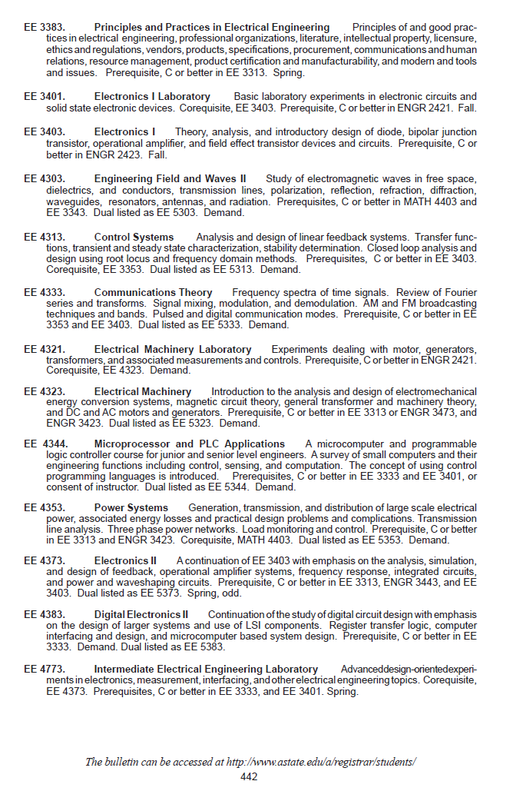te bulletin pages here...

